Aditya Ghanawat
Jul 2019 to Apr 2026 | Handover Document
Sr. Unit Manager – HR Communications

1. Role Mandate & Scope

HR Communications SPOC, you are responsible for end-to-end planning, approvals, creation, governance, and release of HR-related employee communications across BFL. Your responsibility covers all HR functions and communications channels.

2. Approval Flow

Following the approval path ensures accuracy, compliance, and protection for the HR Comms SPOC. It prevents release errors, avoids reputational or legal risk, and maintains audit-ready governance.

2.1 Standard Approval Path:
- Process Owner / Requestor
- HR Communications SPOC
- Lead – HR Communications
- National Lead – HR Communications (for sensitive/critical/org-wide communications)
- HR Leadership (CHRO) for mandated items

3. Campaign Categories & Frequency

HR campaigns fall into predictable, recurring categories that help structure planning and execution. Each category has typical frequencies and communication requirements.

3.1 Campaign Categories + Frequency
Category | What It Includes | Typical Frequency
HR Processes | Appraisal, Goal Setting, MYCI, Leave, Travel, Claims, Compensation | Appraisal (Feb–Mar) yearly, Goal Setting (May–Jun) yearly, MYCI (Aug–Sep) yearly
HR Policies | New policies, revisions, withdrawals, statutory updates | Monthly (varies based on governance cycles)
System Updates | Sigma, Chroma, HR Care, tech implementations, downtimes | 2–4 per month, heavier during releases
Engagement | PureLife, Wellbeing, Desi Daftar, Internal campaigns | Weekly–Biweekly, depending on program
Compliance | Code of Conduct, IT Security, audit guidelines | Quarterly or mandated cycles
Surveys | HRSS, Admin, Rewards, L&D, TA, EAP | Weekly–Monthly, based on team needs
Branch Operations | Closures, reopenings, weather alerts, safety updates | Unpredictable, often high volume
Promotions (Open ID) | Business promos, offers, product banners | Max 1/week, per SOP
Leadership / Org Announcements | Structure changes, recognitions, accreditations | Case-based, often monthly

4. Channel Strategy

4.1 Channel Priority Hierarchy
From highest to lowest priority (based on clarity, governance, impact):
- Email
- HR Bulletin
- Org Bulletin
- MS Teams
- SnapComms
- SMS
- Open (Homepage Banner, Event Tile, Promotions & Campaign)

4.2 Channel Rules

4.2.1 Email
- Primary launch channel
- Best for detailed instructions, policy updates, HR processes
- Vernacular available
- Avoid overuse unless critical
- Keep within ≤150 words unless complex

4.2.2 HR Bulletin
- For HR processes, HR policies, advisories
- Vernacular available
- No images allowed

4.2.3 Org Bulletin
- Only for major org updates & leadership announcements
- Images allowed only for awards/recognition
- Strict approval path

4.2.4 MS Teams (Communicator)
- Use for short nudges & reminders
- Body ≤150 words; CTA ≤4 words
- Great for driving follow-through after email

4.2.5 SnapComms
- Urgent & actionable updates
- 1/day
- Avoid overuse
- Ideal for reminders during Appraisal/Goal/MYCI

4.2.6 SMS
- Use only for time-bound urgency
- Fewer characters; must be concise
- 24h signoff, 4-day slotting

4.2.7 Open (Homepage Banner, Event Tile, Campaigns)
- Good for visibility, teasers, long-running items
- Not for urgent campaigns
- Several formats with varied visibility

4.3 Aditya’s Pro Tips
- Launch on Email, drive momentum on SnapComms & Teams.
- Avoid more than 2 major emails/week — redirect minor updates to Teams.
- Avoid overlapping Appraisal/Policy/C&B emails in the same 48 hours.
- Move reminders to Teams or SnapComms during heavy months (Feb, Aug, Dec).
- Use vernacular wherever the audience is large and pan-India (Email + Bulletins only).
- Always check festival dates, pay cycles, and appraisal windows before slotting.
- Use SnapComms early for cycle-based campaigns to avoid last-minute spikes.
- Open Homepage banners work best for evergreen campaigns, not urgent actions.
- Maintain a 3–4 day gap between high-content campaigns.
- Prioritise readability — simplify every message.

5. Stakeholder Handling

5.1 Policy Team
- Very last-minute, sensitive info
- Needs multiple version checks
- Always validate dates, numbers

5.2 C&B Team
- Deadline-driven
- Usually urgent, with impacts across org
- Needs strict version control

5.3 HRSS
- High bulletin volume
- Often predictable cycles — prepare in advance

5.4 Admin
- Operational alerts, closures, weather
- Usually urgent & high-impact

5.5 L&D
- High creative volume
- Needs brand consistency

5.6 Aditya’s Pro Tips — Stakeholder Edition
- Communications Team (Internal) must invest in awareness campaigns:
  - Road Safety
  - Mental Health
  - Stress & Burnout Indicators
  - High-frequency Sad Demise occurrences → integrate empathy & wellbeing
- For policy + C&B teams: build pre-drafted formats to speed up urgent requests.
- For Admin: maintain ready templates for closures, weather alerts, safety SOPs.
- For HRSS: maintain a monthly bulletin-ready pool to respond faster.
- Treat every sensitive update as employee-impact first, not just a request.

6. HR Cycles

6.1 Major HR Cycles – Annual Summary

Cycle | Launch Period | Peak Activity | Closure
Annual Appraisal | Early Feb | Feb 10–28 | March 1–6
Goal Setting | Mid-May – Early June | May–June reminders | Late June–Early July
MYCI | Last week of August | Sept 1–20 | Sept 20–25 (extensions)
Compensation & Pay Updates | December | December | December
Holiday Calendar | December | — | —
Compliance Cycles | Quarterly | Quarterly | Quarterly

7. Templates

These are email templates that you will require to gather data from your SPOC for various standard communications:

7.1 Downtime Template

Hi Team,
Please share below details to process the Downtime Update.
- System Name:
- Downtime Date:
- Downtime Time:
- Expected Restoration Time:
- Impact Summary:
- Alternate Process (if any):
- For any queries, please connect with the <Process Owner Department>.

7.2 Policy Update Template

Hi Team,
Please share below the details required to process the Policy Update communication:
- Policy Name:
- Type of update (New / Revision / Withdrawal):
- Objective of the update:
- Effective Date:
- Target Audience:
- Final Approved Policy Document Link:
- Summary of changes (Max 4–5 bullet points):

7.3 Engagement Invite Template

Hi Team,
Please share the event details in the below format to proceed with the Engagement Invite:
- Event Name:
- Event Objective:
- Target Audience:
- Event Date:
- Event Time:
- Venue / Meeting Link:
- Dress Code (if any):
- Registration Link / CTA:
- Collaterals Required (Email / MS Teams / SnapComms):

7.4 Leadership Mailer Template

Hi Team,
Please share the details required for preparing the Leadership Mailer:
- Leader’s Name:
- Leader’s Designation:
- Context of the communication:
- Key message outline (Max 4–5 bullet points):
- Tone Preference (Formal / Inspirational / Directive):
- Attachments (if any):

7.5 HR Process Change / System Enhancement Format
Hi Team,
To process your HR Process Update / System Enhancement communication, please share the below details:
- Process/System Name:
- Nature of Change:
- Objective of Change:
- Effective Date:
- Target Audience:
- What changes for the employee (Max 4 points):
- Escalation Contact:
- Process Owner Department:
The HR Communications Team will prepare the mailer after receiving the above information.

7.6 Event Reminder Format
Hi Team,
Here is the format for Event Reminder details:
- Event Name:
- Event Date:
- Event Time:
- Venue / Meeting Link:
- Reminder CTA:
- Any items to carry (if applicable):
Reminder will be released based on available slot and approval workflow.

7.7 Survey Launch Format
Hi Team,
Please provide the following details for the Survey Launch:
- Survey Name:
- Survey Objective:
- Target Audience:
- Survey Link:
- Launch Date:
- Closure Date:
- Estimated Time to Complete:
- Any incentives (if applicable):

7.8 Festival Greeting Format
Hi Team,
Please share the below details for processing the Festival Greeting:
- Festival Name:
- Preferred Tone (Warm / Formal / Minimal):
- Any statutory / business instructions (if applicable):
- Creative requirement (Yes / No):
- CTA (if any):

7.9 Monthly Initiative Launch Format
Hi Team,
Please share the launch details in the below format:
- Initiative Name:
- Objective of the initiative:
- Target Audience:
- Start Date:
- End Date:
- Owner Function:
- Key Deliverables (Max 4 bullets):
- Tracking Method (if any):
- CTA:

7.10 Leadership Joiner Announcement Format
Hi Team,
Please share the Leader details in the below format:
- Leader’s Name:
- Designation:
- Business Unit:
- Effective Joining Date:
- Previous Experience (Max 3 bullets):
- Role Summary at BFL (Max 3 bullets):
- Leader’s Photograph:

7.11 Sad Demise Format

Hi Team,

Please share the employee’s details in the below format:

- Employee Code
- Name (First Name - Last Name)
- Age (In Years)
- Birth Year
- Department
- Branch Location
- State
- Date & Cause of Death
- Employee Photo

After you share this, We will share the email with you for your approval.

Please note: The final approved email will be released only to the Employee’s department and the Branch Location.

7.12 Crowd Funding Format

Hi Team,

I need your BH approval & NM HRP’s approval for initiating the crowdfunding process.

Once you get the approvals, please share the same with me along as attachments with the employee data in the below format:

- Employee Name:
- Employee Dept:
- Employee Location:
- Cause for crowdfunding:
- Account name:
- Account number:
- Bank:
- IFSC:
- GPay/ UPI number:
- GPay/ UPI QR CODE:

Once this is shared, we will share the Crowd Funding Email with you, you can release this to your respective department and use the subject line: Let's Come Together For <Employee Name>

8. Analytics

8.3 Monthly Campaign Peaks:
- Jan: Pre-Appraisal prep, HR Updates
- Feb: Appraisal Launch, Live, Reminders
- Mar: Appraisal Closure, Extensions
- Apr: Sigma/Chroma Updates, HRSS Processes
- May: Goal Setting Launch
- Jun: Goal Setting Reminders
- Jul: Training, Engagement
- Aug: MYCI Launch
- Sep: MYCI Reminders
- Oct: Engagement + System updates
- Nov: Wellbeing + Compliance
- Dec: Flexi Pay, Holiday Calendar
These are consistently the highest activity spikes:
8.4 Top 3 busiest months across 7 years

Rank | Month | Reason
1 | February | Annual Appraisal Launch + Live + Reminders (heavy multi-channel load)
2 | March | Appraisal Closures + Extensions + Final reminders
3 | June | Goal Setting reminders, L&D, mid-year HR updates
Below is a clearer mapping of what caused each major peak year-wise:
Year | Peak Month | What Caused the Spike
2020 | April–May | COVID communications (lockdowns, safety, closures, Sigma, well-being)
2021 | April–May | 2nd wave COVID comms, closures, meal service, safety advisories
2022 | February | Appraisal FY22 – tight reminder cluster (10–28 Feb)
2023 | February | Appraisal FY23 Live + SnapComms + Steps reminders
2024 | May–June | Goal Setting peaks + increased Sigma/Chroma upgrades
2025 | August–September | MYCI launch + multiple extensions
2026 | January–March | Appraisal FY26 (pre-launch + launch + reminders + extension)
The biggest peaks happen when Appraisal or MYCI aligns with additional events like system changes or compliance cycles.

8.5 Top 10 High-Volume Campaign Families
- Lockdown Diaries (massive 2020 volume)
- Be Healthy, Stay Safe (PureLife)
- When at Home (COVID WFH Series)
- Branch Reopening
- Corona Virus Advisory / Updates
- Manager Tips
- Investment Declaration & Tax Regime Updates
- Claims Submission Reminders
- iCare / Wellbeing
- Desi Daftar

8.6 Insights:

Insight 1 — Lockdown Diaries is the single largest campaign family
  - It dominated 2020 with 30+ entries/month in April–May.

Insight 2 — PureLife content creates mid-volume but sustained peaks
  - Whenever PureLife launched a theme, it created consistent daily SMS + email pairs.

Insight 3 — Branch Reopenings (2020–2021) caused unpredictable spikes
  - Especially when advisory + SMS + bulletin + follow-ups all dropped the same day.

Insight 4 — HRSS drives predictable bulletin peaks
  - Tax, claims, mediclaim, Form 16, Form 12BB → perfectly cyclical every year.

Insight 5 — Promotions (Open ID) show weekly rhythm
  - Every Friday tends to have BFSL/BF Markets promotional traffic.

Insight 6 — Some months see “double peaks”
  - Feb = Appraisal + Sigma updates
  - Aug = MYCI + iCare drives
  - Dec = Flexi Pay + Holiday Calendar + Compliance

8.7 Busiest Months – 7-Year Average
This bar graph highlights volume trends across months.

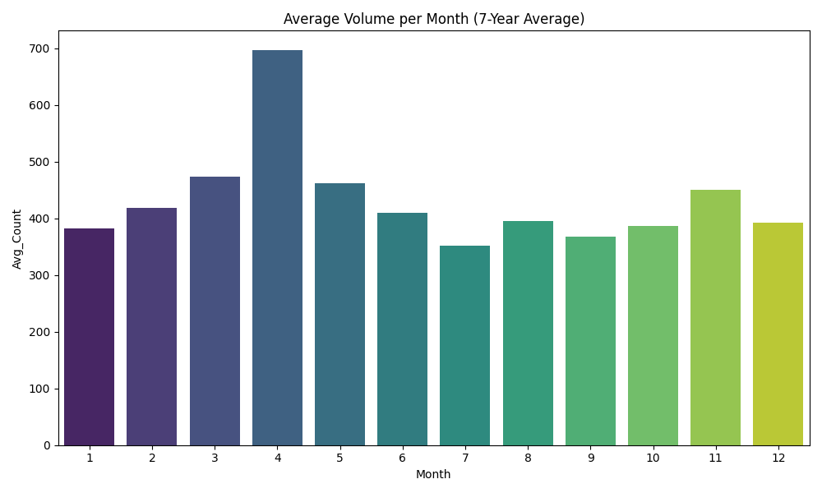

8.8 Anomalies Heatmap (Year × Month)
This heatmap visually surfaces outlier spikes such as COVID rounds, Appraisal cycles, MYCI bursts, and more.
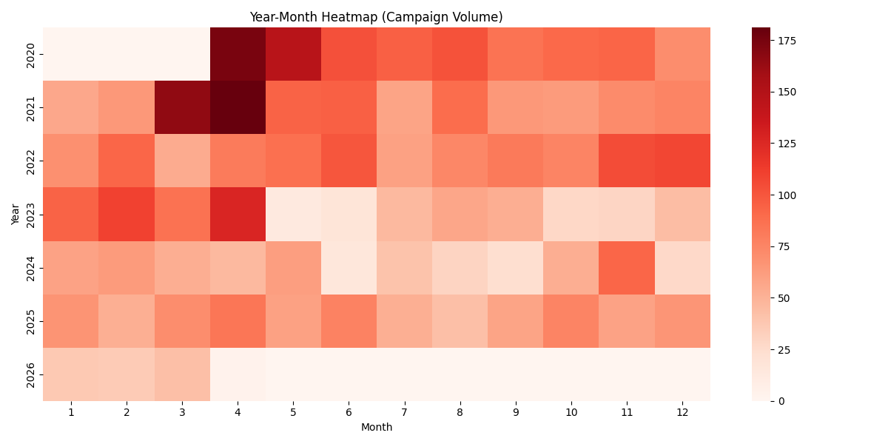

8.9 Top Channels by Volume

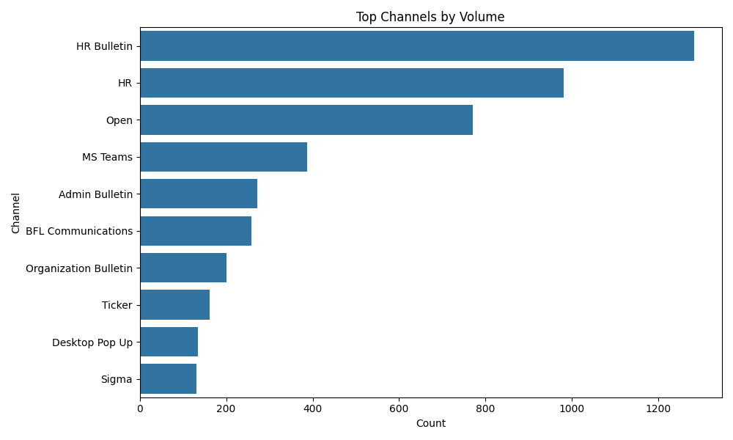

8.10 Top Requesting Teams

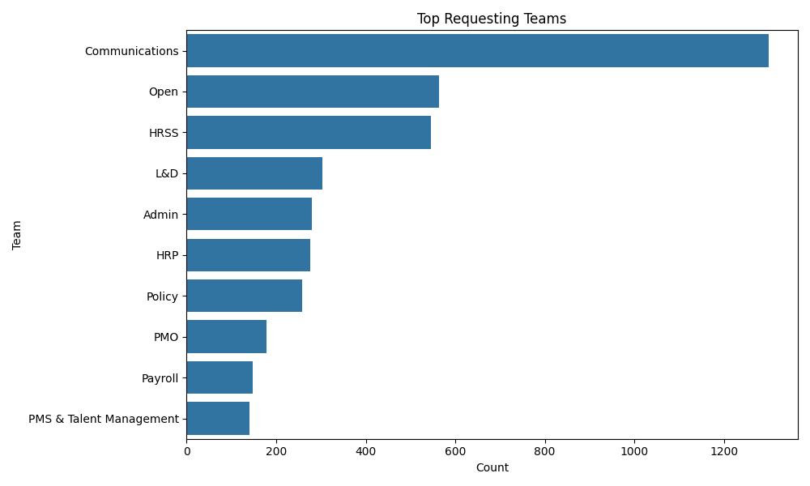

8.11 Monthly Trends (Communications sent)
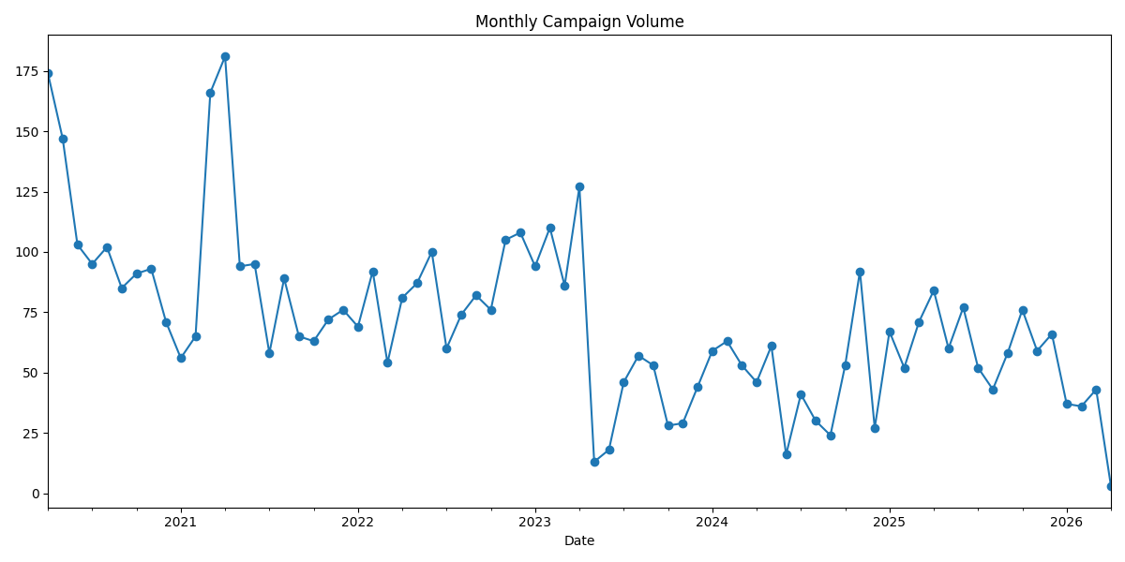

9. Successor Operating Model

9.1 Daily
- Check approvals from stakeholders
- Review upcoming campaign slots
- Validate copies + creatives for accuracy, tone, and compliance
- Check Open homepage data for relevancy
- Clear all pending clarifications with teams

9.2 Weekly
- Slot campaigns for next week
- Review overlapping campaign timings
- Update internal HR Comms tracker
- Inspect channel loads (email, Teams, SnapComms)

9.3 Monthly
- Update HR Comms calendar
- Archive past campaigns for audit
- Assess campaign impact metrics
- Sync with HRSS + Policy + C&B on expected requests

9.4 Quarterly
- Confluence preparation
- Clean-up documentation
- Channel performance review

10. Pro Tips

- Launch on Email, drive reminders on SnapComms & Teams.
- Avoid sending more than two major emails a week.
- Pre-create templates for Policy & C&B teams due to urgency.
- HRSS monthly bulletins can be pre-planned.
- Integrate awareness campaigns: Road Safety, Mental Health, Wellbeing.

I wish you all the best – in case you have any further queries ask my bot: https://gemini.google.com/gem/12vOfcHSms0U1nFKD8enWm_RcFrGivyxO?usp=sharing

